POWERBI DASHBOARD DOCUMENT

The dashboard is an interactive visual representation of the Superstore dataset, created using Power BI. It consolidates charts, KPIs, and filters in one view to help analyze sales, profit, and product performance efficiently.
Charts:
  - Line Chart: Shows sales trends over time, helping to identify seasonal patterns or growth trends.
  - Column Chart: Displays profit by sub-category or region, highlighting high-performing areas.
  - Pie Chart: Represents the proportion of sales for each category, making it easy to see which categories contribute most.
  - Box Plot: Shows the distribution of profit across categories, including outliers, helping identify risky or high-value segments.
KPIs (Key Performance Indicators):

  - Total Sales, Total Profit, Total Orders, Average Profit per Order. These cards summarize the overall business performance at a glance.

Slicers / Filters:
  - Allow dynamic filtering by Region, Category, and Order Date, so users can focus on specific segments of data and explore trends interactively.

  - 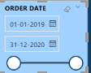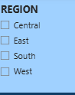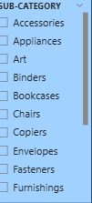

Purpose and Insights:

- The dashboard provides a single view of critical business metrics.
- It allows decision-makers to quickly spot trends, compare categories or regions, and detect anomalies.
- By combining charts, KPIs, and filters, it makes the data actionable and easy to interpret.

OVERALL DASHBOARD:

